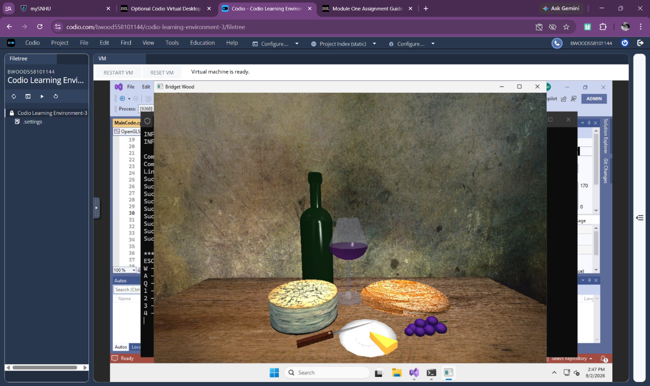

Setting up OpenGL in Visual Studio took more attention than I expected because the project depends on several files and libraries being organized correctly. I opened the OpenGLSample solution, checked that everything loaded without missing-file errors, and then found the window-title definition in MainCode.cpp. I changed the title from “OpenGLSample” to “BridgetWood,” rebuilt the project, and ran it again to confirm that the change worked. Once the sample opened and displayed the wine glass, cheese, and bread, I knew the basic OpenGL setup was working correctly.
My main challenge was understanding how all of the pieces of the sample project connect. OpenGL is still new to me, so parts of the code such as the rendering loop, shaders, and camera controls are not completely clear yet. I handled the setup by making one change at a time and running the project after each change so I could tell where a problem came from if something stopped working. I also double-checked the project folders and Visual Studio settings instead of changing multiple things at once. At this point, the sample runs successfully and I do not have any errors that need instructor help, but I would like to better understand how the shader code and rendering loop work together as we begin building our own 3D scenes.

